GCP Firestore [Non SQL DB]

Enable the api [In-case it is not enabled]

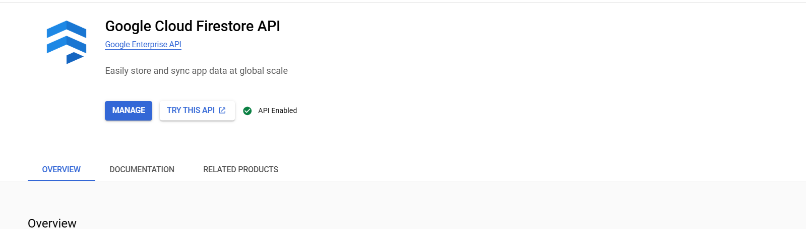

Click on View all products

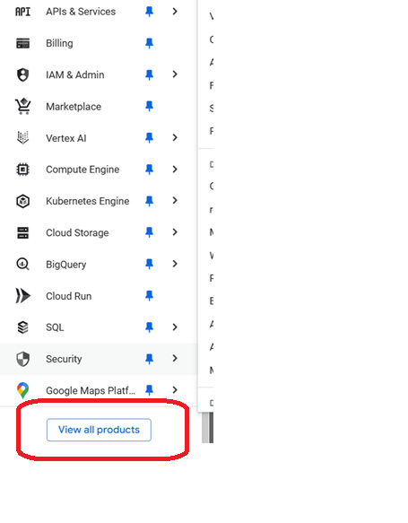

Click on Databases

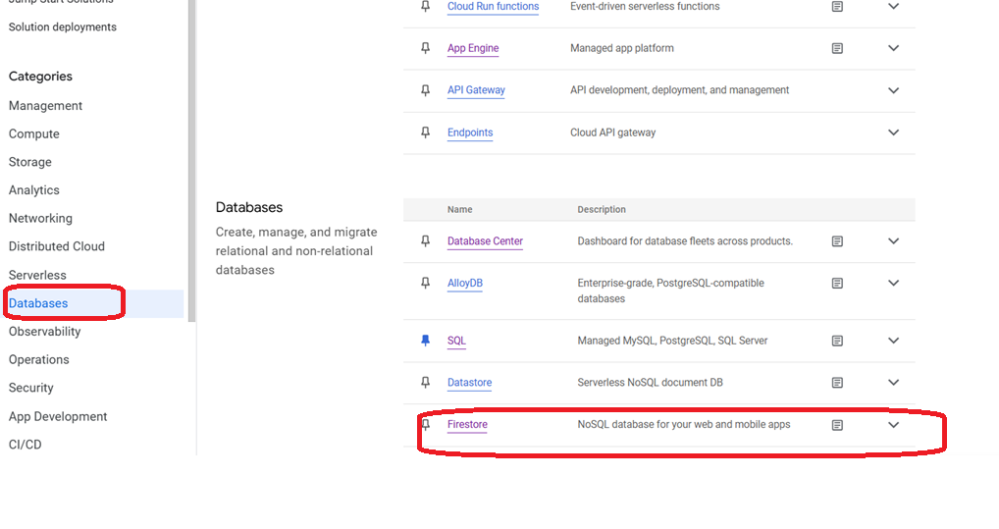

Click on Create Database

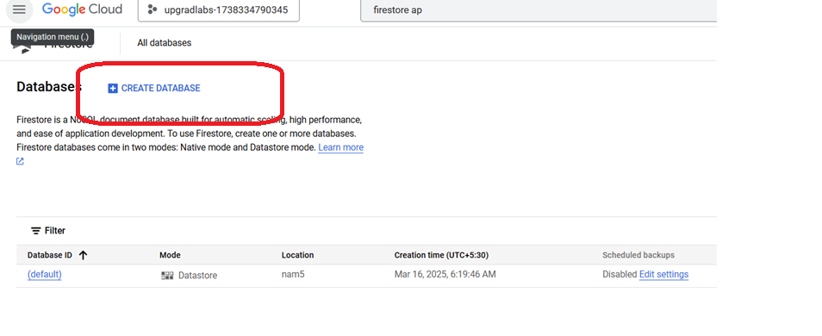

Select the mode[native]

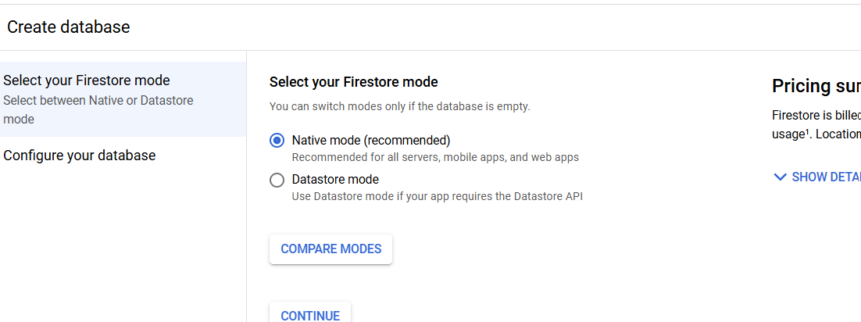

Security rule

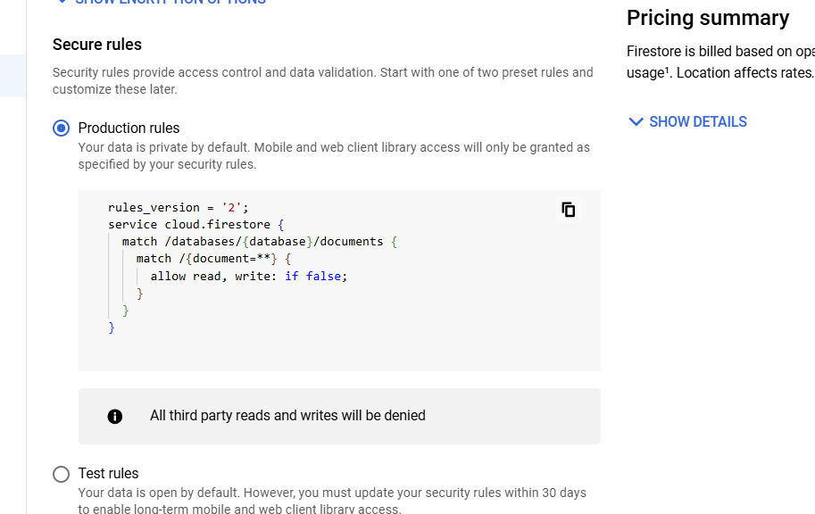

Click on create database

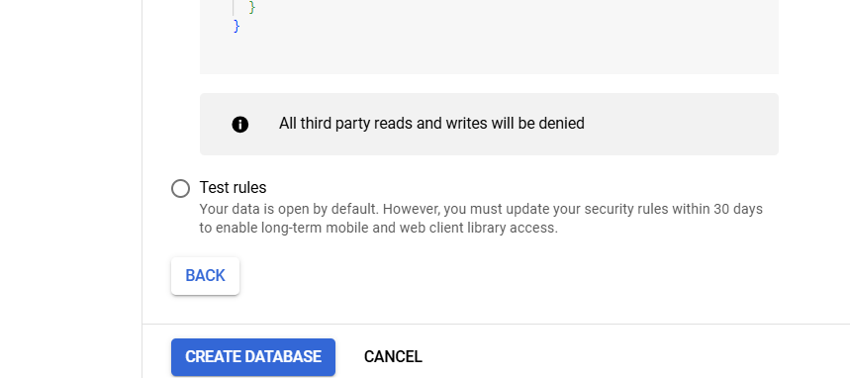

Click on start collection

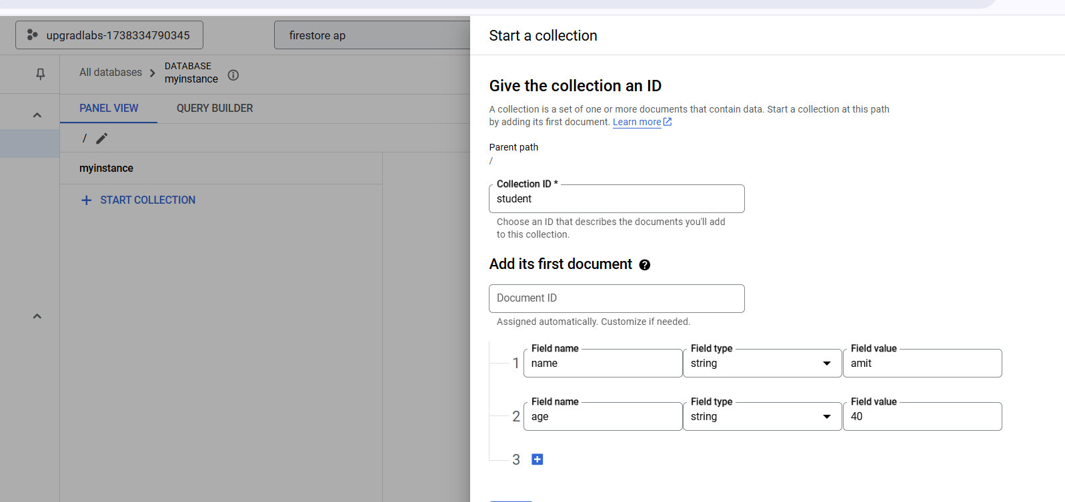

Add few entries in the collection

Check the collection

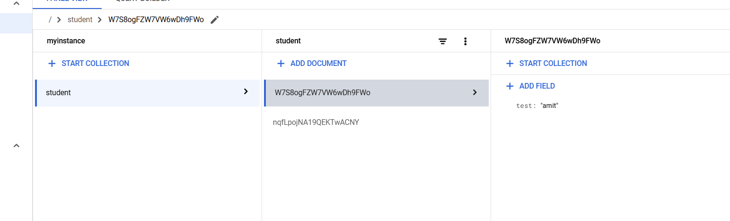

You can try to add different field with the collection